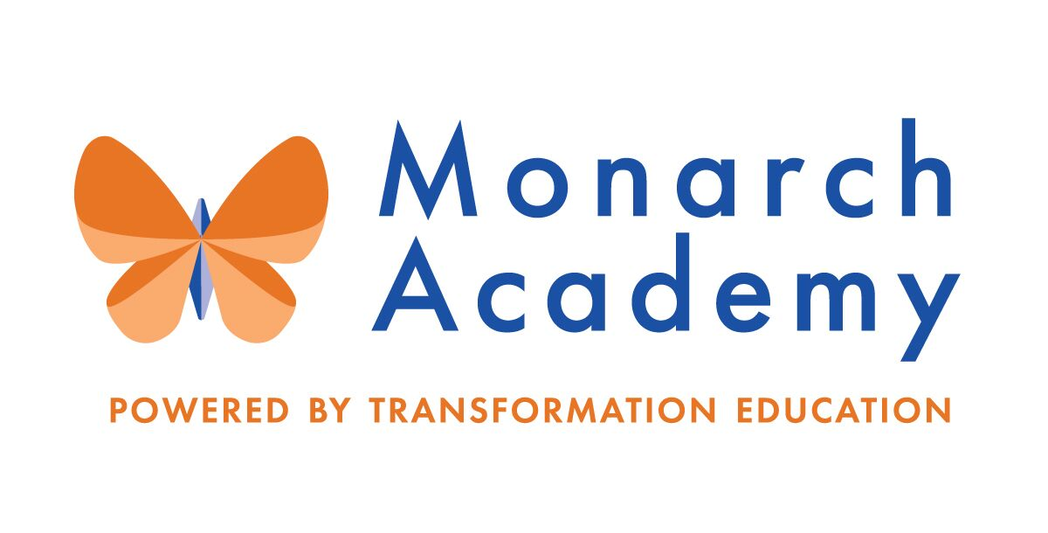
Monarch Academy, Anne Arundel
Board of Directors Meeting
Wednesday, May 11, 2022
ZOOM
6:00 - 8:00 p.m. OPEN BOARD MEETING

Attendees | Not in Attendance | Monarch Staff | The Children’s Guild
Dr. Sissy Jimenez  Janine Fratantuono  Kandace Hoppin  Carley Czyzewski  Elizabeth Noble | Dominique Barnes  Eric DeVito  Brittany Jones  Megan Philbeck  Ray Szyperski | Kim Jakovics, Glen Burnie  Emily Abell, Global  Molly Courtien,  Annapolis  Shae Johnson, Annapolis | Kathy Lane  Brandon Turner  Charley Gordon  Susan McFaul  Kelly Schwalbert
Minutes

- Call to Order – Dr. Jimenez
Monarch Anne Arundel Meeting called to order at 6:05 pm by Dr. Jimenez.

- Public Comment
Ms. Noble is a parent of a kindergartener and fourth grader at Monarch Annapolis. She is currently serving as PTA President but has stepped down at the end of this school year. She articulated that she has actively advocated for students and teachers. She voiced her concerns about turn over in leadership and its impact on students.

- Review Minutes – Dr. Jimenez (see attachment) (04:33 – 06:05)
Unable to approve minutes due to lack of quorum.

- Current Financial Report – Mr. Gordon (06:20-13:53)
Mr. Gordon reviewed the financials ending March 2022 (see attached reports for details). Trend Analysis 03.31.2022 YTD

- Currently revenues are above budget but ahead of the prior year.
- Current operating expenses are above budget and larger than the prior year
- This is creating a positive change in net assets below budget and lower than the prior year.

- Principal’s Report
- Monarch Global – Ms. Abell (15:13-32:39)
https://www.smore.com/2fyn7

  - Enrollment is down to 794 students based on families who have moved during the school year.
  - Staffing needs were reviewed; nine staff on maternity leave. Projected openings for next school year have been identified and are actively interviewing to fill those roles. Four substitute teachers are now in permanent roles to fill some of the vacancies.
  - Third thru eighth grade students are currently participating in state testing.
  - Focused on the School Improvement Plan for next year. Reviewed data and conducted audits to determine whether or not they did what they said would do.
  - Teachers answered questions about what they saw from data protocol, inferences, data questions, concerns, and next steps.
  - Celebrated the nomination of Brooke Syring as Teacher of the Year.
  - TranZed Eight
    - MGA Student ABIDE team begins to have an influence on MGA, Acceptance, Belonging, Inclusion, Diversity, Equity
    - 8th grade Student ABIDE team spearheads MGA week of Culture June 13-17
- Well Being Profile – Weekly drum circles with 4th and 5th grade students in collaboration with MGA counselors and Creating Communities.
- Enriched Experiences
  - Elementary and Middle School Media Specialists attend AACPS Literature Convention
  - 1st graders visit Clark Elioak farm
  - 3rd graders visit Baltimore Science Museum
  - Stories Heal after school Program
- Behavior Motivation Continuum
  - Staff are implementing PBIS structures within grade level teams.
  - MGA SOAR matrix is part of regular discourse within the school, institutionalized practice.
- MGA Staff Appreciation Week May 3rd – 5th 2022
- Uniform Drive June 8th, 2022 Parents can pickup uniforms at the bus loop from 8:30am to 10am.
- IB program where students are able to take their learning outside of the building
- AVID – will start interviewing 5th graders that are interested in taking up an AVID elective.

- Monarch Glen Burnie – Ms. Jakovics 33:09 – 48:54)
https://www.smore.com/pk15b

  - Ms. Jakovics was named Maryland Charter School Principal of the Year by Maryland Charter School Alliance.
  - Zakiyah Weddington named one of the Charter School Students of the Year.
  - Everyone is invited to facilitate a fifth-grade passage presentation.
  - Enrollment has more seventh and eighth graders in the lottery than usual.
  - Staffing needs were reviewed for current positions and for FY 22/23.
  - The work plan for 2021 – 22 was reviewed.
  - Took 220 middle school students to North Bay Educational Center for a week of camping and hands on learning.
  - 5th grade students work with the Department of Natural Resources to study biodiversity and the health of our on-site natural habitat.
  - Focus on empowerment and well-being for students.

- Monarch Annapolis – Mr. Johnson (56:05 – 1:06:07)
https://www.smore.com/1szpt

  - Student enrollment is K-5 694, PreK 60, and 164 enrolled in eSchool.
  - Construction – the penthouse remodel almost entirely complete.
  - IB Learning Community Updates – Authorization date is Friday, June 2, 2022.
  - Save the Date – International Fair Saturday, May 21, 2022.

- Board membership – Dr. Jimenez & Kathy Lane (1:06:53 – 1:18:29)
  - Recommendations and Nominations for new members
    - Mr. DeVito will be stepping down as a board member and Mr. Matthews also recently stepped down. Actively recruiting for new board members based on needed expertise.
    - Dr. Jimenez’s term as Chairperson is complete and is nominating Kandace Hoppin to be the next Chairperson.
    - Ms. Lane proposed these candidates be reviewed and voted on via email.
    - Two candidates are being nominated and resumes were distributed for Dr. Rotunda Cooper and Rashida Major.
    - Unable to vote due to not having a quorum.

- Committee Membership (1:27:43 – 1:29:33)

Board directors were asked to read through the different committees and start thinking about which they would like to serve on. Ms. Lane will ask Mr. DeVito and Mr. Szyperski if they have any recommendations for directors.

Current Enrollment by School and Recruitment Strategy – Mr. Turner (1:19:05 – 1:27:10)

Mr. Turner spoke on the recruitment efforts:

- Current registrations for Annapolis are at 94 and numbers are up compared to last year’s 51 registrations.
- Communicated through Monarch Global and Glen Burnie wait list families that they can apply to Monarch Annapolis.
- Mr. Turner feels positive about meeting the MAA goal of 750 students.
- The focus has been on retention efforts and will follow up quarterly with new families next year to try to ensure they are having a positive experience.
- Adjournment – Dr. Jimenez (8:00 pm)
The meeting was adjourned at 7:34 p.m.

