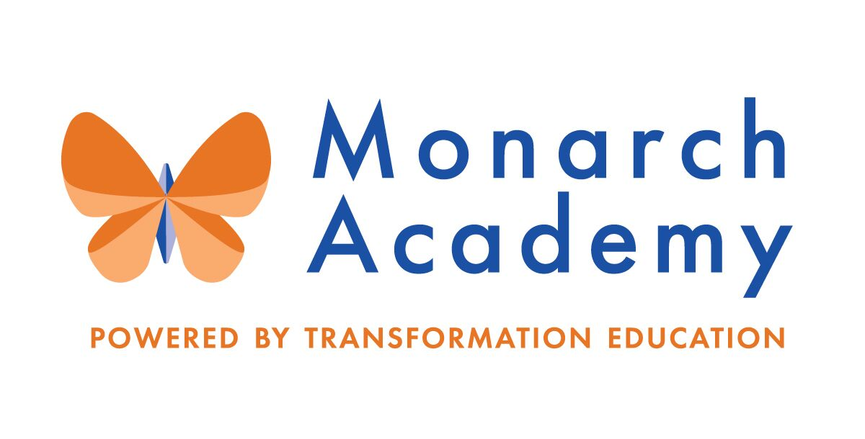
Monarch Academy, Anne Arundel
Board of Directors Meeting
Wednesday, March 16, 2022
ZOOM
6:00 - 8:00 p.m. OPEN BOARD MEETING

Attendees | Not in Attendance | Monarch Staff | The Children’s Guild
Dr. Sissy Jimenez  Dominique Barnes  Eric DeVito  Janine Fratantuono  Kandace Hoppin  Brittany Jones | Carley Czyzewski  Elizabeth Noble  Megan Philbeck  Ray Szyperski | Kim Jakovics, Glen Burnie  Emily Abell, Global  Charlette Manbeck,  Annapolis | Kathy Lane  Brandon Turner  Charley Gordon  Susan McFaul  Kelly Schwalbert
Minutes

- Call to Order – Dr. Jimenez
Monarch Anne Arundel Meeting called to order at 6:05 pm by Dr. Jimenez.

- Public Comment – Dr. Jimenez
No public comment.

- Review Minutes – Dr. Jimenez (see attachments) (27:55 – 28:34)
The board reviewed and approved the minutes from January 12, 2022.

- Current Financial Report – Mr. Gordon (28:44-36:39)
Mr. Gordon reviewed the financials ending December, 2021 (see attached reports for details). Trend Analysis 12.31.2021 YTD

- Currently revenues are below budget but ahead of the prior year.
- Current operating expenses are above budget and larger than the prior year
- This is creating a positive change in net assets below budget and lower than the prior year.

- Principal’s Report
- Monarch Glen Burnie – Ms. Jakovics (0 – 27:08)
https://www.smore.com/pk15b

  - The school has been using experts to align with expeditions and using field work opportunities in math.
  - Enrollment offers went out based on the lottery; some attrition based on families moving.
  - Staffing needs were reviewed for current positions and for FY 22/23.
  - Evaluating hiring a Dean of Students position and working to understand how best to structure the position. It has been a challenging year for students.
  - Greenhouse is in fabrication and everyone loves the turf field.
  - Expeditionary Learning mid-year review held in February which allows us to gage progress and make adjustments. Significant areas to celebrate especially given the learning interruption students faced.
  - The work plan for 2021 – 22 was reviewed.
  - Focus on empowerment and well-being for students.
  - Community project for the Maryland Food Bank for the Afghan refuge community. Acts of kindness week celebrated.
  - It is important to voice opinion for Anne Arundel County to hire a superintendent in favor of charter schools. The AACPS will be soliciting stakeholder feedback. Ms. Lane will create language to share with the board for emails to be sent to the AACPS board. A suggestive message will be created for parents as well.

- Monarch Global – Ms. Abell (37:10-51:20)
https://www.smore.com/2fyn7

  - Enrollment is down to 794 students based on families who have moved during the school year.
  - Staffing needs were reviewed; nine staff on maternity leave. Projected openings for next school year have been identified and are looking to begin recruiting.
  - Celebrated retiring principal Donna O’Shea and dedicated the library to her.
  - TranZed 8 in Action
    - MGA Student ABIDE team is beginning to have school impact with school voice
    - Well-being profile – creating communities with students participating in drum circles with session provided through a grant.
    - Enriched experiences – creating experiences with creative in-school field trips; 1/3 of student population are participating in nine virtual spring clubs. Love of learning month celebrated in February.
    - Brain literacy – completed student led conferences in grades 1 – 8 focusing on the students’ progress.
    - Behavior Motivation – Implementing PBIS structures with experiences as rewards.
    - Community – PTA provided staff snacks; Red Cross donations; door decorating contest for Black History Month.
    - AVID – working to grow this program school wide
    - Lion King Jr. musical will be held March 31 – April 3rd (see flyer).

- Monarch Annapolis – Ms. Manbeck (52:38 – 1:17:10)
https://www.smore.com/1szpt

  - Student enrollment is 762 including PreK; 164 enrolled in eSchool. A few losses with some students returning to the building at their home schools.
  - Construction – the penthouse remodel is moving quickly; work should be completed by the end of March.
  - IB PYP – goal was 100% of MAA staff trained; final course in process for remaining teachers.
  - IB Learning Community Updates – PYP Parent Learning Walk on March 22nd to show what PYP is and what makes the program different.
  - Focus on well-being – focus has been on safety i.e. community issues, Erin’s law to teach on child abuse, etc.
  - Wellness Wednesdays for staff to practice healthy habits.
  - Enriched environments & experiences – literacy team building teaching capacity. Reviewed celebrations and events that have been held.
  - Bullying assembly to give some clarification to help students understand what is bullying and what it isn’t.

- Board membership – Dr. Jimenez (1:17:42 – 1:28:23)
  - Recommendations and Nominations for new members
    - Mr. DeVito will be stepping down as a board member and Mr. Matthews also recently stepped down. Actively recruiting for new board members based on needed expertise.
    - Two candidates are being nominated and resumes were distributed. Ms. Lane proposed these candidates be reviewed and voted on at the May board meeting. It would be helpful to recruit from parent groups as well. Each principal could add a request to the newsletter.

- Committee Membership (1:28:32 – 1:47:15)

The goal is to break the board into committees; this information could be used to recruit for Board Members. We will wait until the new directors start before assigning committees. Backgrounds sought for new directors are legal, real estate, architectural, construction, finance, marketing, nonprofit fundraising, business owners in the community, especially Annapolis.

Current Enrollment by School and Recruitment Strategy – Mr. Turner

Mr. Turner spoke on the recruitment efforts.

- Applications for Annapolis are at 118 and 40 eschool applications.
- Communicated through wait list families that they can apply to Monarch Annapolis.
- Open house held and a number of the parents are going through the registration process.
- Focus has been on improving our structure and process on recruitment.
- Marketing efforts have improved with letting people know we exist. Mr. Turner feels positive about meeting the MAA goal of 750 students.
- The focus has been on retention efforts and will follow up quarterly with new families next year to try to ensure they are having a positive experience. The goal is adding value and creating schools that the students want to attend.
- The team has been thinking outside of the box on ways to engage families. An example of this is the creation of a video with a Towson University basketball player giving a tutorial on dribbling drills which will be used as a recruitment tool. Will be evaluating other sports or arts for other opportunities for students to engage. The plan is to target families that we have already worked with for the basketball video. If a good response we will follow up with a basketball shooting video and then eventually an in-person event.

- Adjournment – Dr. Jimenez (8:00 pm)
The meeting was adjourned at 7:50 p.m.

