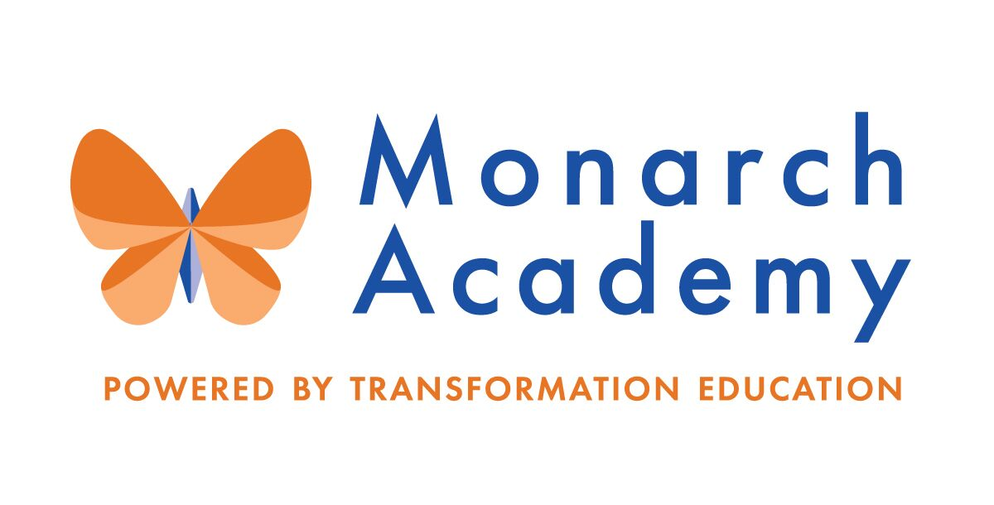
Monarch Academy, Anne Arundel
Board of Directors Meeting
Wednesday, January 12, 2022
ZOOM
6:00 - 8:00 p.m. OPEN BOARD MEETING

Attendees | Not in Attendance | Monarch Staff | The Children’s Guild
Dr. Sissy Jimenez  Carley Czyzewski  Brittany Jones  Megan Philbeck  Dominique Barnes  Elizabeth Noble  Kandace Hoppin  Janine Fratantuono | Loise Taliaferro  Marc Rodriquez  Amber Marcheso  Shae Delfino  Eric DeVito  Angela Balsamo  Ray Szyperski  Jess Deinlein | Kim Jakovics, Glen Burnie  Emily Abell, Global  Charlette Manbeck,  Annapolis | Kathy Lane  Aleisa Fries  Brandon Turner  Charley Gordon
Minutes

- Call to Order – Ms. Lane
Monarch Anne Arundel Board Meeting called to order at 6:04pm by Ms. Lane on behalf of Dr. Jimenez.

- Public Comment – Ms. Lane
None
- Current Financial Report – Mr. Gordon
- Current year revenues are below budget but ahead of prior year
- Current year operating expenses are below budget but larger than last year
- Current year expenses are offsetting lower revenues, creating a positive change in net assets in excess of budget, but lower than prior year
- Expenses are running below due to staffing costs (Currently employing less staff than projected)

- Review Minutes – Dr. Jimenez
- The meeting minutes from September 8, 2021 meeting were reviewed and approved by the Board
- The meeting minutes from November 10, 2021 meeting were reviewed and approved by the Board
- Principal’s Report
- Monarch Glen Burnie – Ms. Jakovics
https://www.smore.com/y3hxpd
- 8 students have transferred since last report due to families moving out of state or transitioning to home schooling
- Explained Work Plan
    - Conducted a survey to determine whether students felt physically safe in the classroom with their teacher
- 80-85% felt safe
- The mode for negative answers was “loud noise and mask use”. No common threat of bullying. This has been referred to Student Services Team for group processing
- The mode for feeling safe was “the teacher makes a difference and the impact of mask use”
- Focusing on the Well-Being of staff by hosting team-building professional development workshops and events
- The PTA and Community Dream Team sponsored event for families and teachers
- Monarch families provided financial assistance to 20 families for the winter holiday season
- Processed 52 COVID cases from 12/23-1/11
- 22 quarantined on 1/11/22
- There are staffing shortages due to COVID positive cases and childcare (resulting from closures due to COVID)

- Monarch Global – Ms. Abell
https://www.smore.com/pzg5f
- There are staffing shortages due to upcoming and current Maternity Leave and COVID positive cases
- Several students have transferred from MGA due to families moving out of state
- 120 students and 19 staff members reported COVID positive since the start of the school year
- 22 quarantined as of 1/11/22
- PTA provided “Friendsgiving” and breakfast for staff throughout the holidays
- Currently running 2 AVID programs
- Goal is to become a site of distinction in the next 5 years
- Ms. Abell is hosting monthly “Coffee with the Principal” events to meet families in an effort to provide feedback and support to and from the community
- MGA participated in a coat drive with Maryland City Elementary School. Any coats left in the “lost in found” will be donated by the PTA if not claimed
- Board members are invited to attend the luncheon at MGA on January 31, 2021 at 11am-1pm to dedicate the Media Center to the founding principal, Donna O’Shea and honor her contributions to MGA and AA County.

- Monarch Annapolis – Ms. Manbeck
https://www.smore.com/yrhqsg
- Ms. Manbeck has returned and resumed her role as Principal
- Thank you to Ms. O’Shea for filling in in Ms. Manbeck’s leave of absence!
- Several students have transferred due to families moving out of state. Numerous students have transferred to eSchool
- Construction has begun on the Penthouse remodel
- This will add two additional classrooms, bathrooms, workstations, and teacher planning space
- Teachers are attending workshops to become IB trained. Once trained, the teachers will host workshops to train the other teachers, with the goal to have 100% of all staff trained
- Classroom teachers have started Community Building Circles 3-5 days per week
- MAA School Counselor, Ms. Johnson, has partnered with 18 Middle Schools to transition 5th graders into those schools and magnet programs throughout the county
- This year, the school will transition to a Schoolwide Title I school
- The school had to transition to short term virtual synchronous instruction on 12/20-12/23 due to high number of COVID cases
- Building underwent a deep clean
- Ventilation was assessed and upgraded as necessary
- New cleaning company has been contracted to clean/disinfect every evening
- 2 daytime porters assist with high touch cleaning throughout the day
- Currently 6 positive student cases and 0 staff

- Board membership – Dr. Jimenez
  - Recommendations and Nominations for new members
- The Children’s Guild, Ms. Lane, will be meeting with the Maryland Charter School Board Network for support in recruiting new Board members
- Dr. Jimenez requests that any recommendations from current Board members are e-mailed to her and Ms. Lane for review and consideration
- Dr. Jimenez recommends that we reach out to parents/families within the schools to determine interest of joining the Board
- Ms. Lane will review the by-laws to determine if this is a possibility

- Committee Membership- Appoint Chairs and Committee members – Dr. Jimenez
(Appointing Committees will be a tabled agenda item until more Board members are recruited)
  - Governance Committee
- The current Board will be appointed as The Governance Committee. New members will be assigned to a committee based on their experience and expertise
  - Marketing, Enrollment, Finance & Facilities Committee (MEFF)
- Current Enrollment by school and Recruitment Strategy – Mr. Turner
- The new Marketing Department is revamping the Marketing Strategic Plan to provide more “how to” options and opportunities for enrollment
- Initiating new marketing efforts that will expand targeted audiences
- More information will be provided at next meeting
  - Parent Engagement, Academic Excellence & Compliance Committee (PEAC)

- Other Business
  - Vote on meeting preference- virtual or in person
- Dr. Jimenez decided that the next meeting in March will be virtual and this question will be reviewed again at that time
- Dominique Barnes is introduced as a new Board member, PTA President at Monarch Global Academy
- Adjournment – Dr. Jimenez
Monarch Anne Arundel Board Meeting adjourned at 7:37pm.

