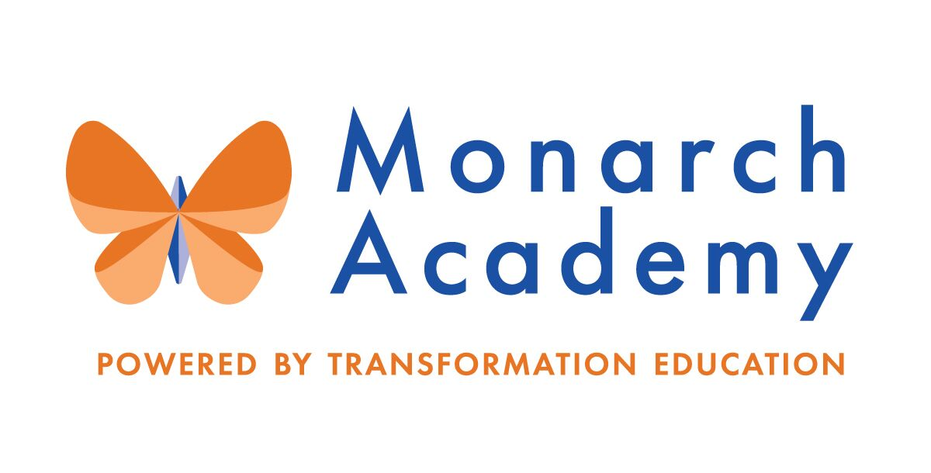
Monarch Academy, Anne Arundel
Board of Directors Meeting
November 10, 2021
ZOOM
6:00 - 8:00 p.m. OPEN BOARD MEETING

Attendees | Not in Attendance | Monarch Staff | The Children’s Guild
Kandace Hoppin  Carley Czyzewski  Ray Szyperski  Jess Deinlein | Dr. Sissy Jimenez  Brittany Jones  Loise Taliaferro  Megan Philbeck  Janine Fratantuono  Marc Rodriquez  Amber Marcheso  Shae Delfino  Eric DeVito  Angela Balsamo | Kim Jakovics, Glen Burnie  Donna O’Shea, Annapolis  Emily Abell, Global  April Murphy, Global | Kathy Lane  Aleisa Fries  Brandon Turner  Charley Gordon
Minutes

- Call to Order – Ms. Hoppin on behalf of Dr. Jimenez
Monarch Anne Arundel Board Meeting called to order at 6:04pm by Ms. Hoppin on behalf of Dr. Jimenez.

- Public Comment
None
- Review Minutes – Ms. Hoppin on behalf of Dr. Jimenez
The meeting minutes from September 8 could not be formally approved due to lack of quorum.
- Current Financial Report – Mr. Gordon
The budget quarter ended on September 30, 2021.
- Current year revenues are below budget but ahead of prior year
- Current year operating expenses are below budget but ahead of prior year
- This is mostly due to onsite learning vs remote learning last year, specifically increased transportation and facilities related costs

- Principal’s Report
- Monarch Glen Burnie – Ms. Jakovics
https://www.smore.com/zdsy0
- ‘Monarch Academy Work Plan goals’ updates were provided
- MGB created a “Crew Council” for students to provide an opportunity for leadership development and student feedback
- The turf field has been installed. Teachers are using this new refined space for instruction in addition to recess
- Kindergarteners and 8th graders have taken “field work” trips outside of the school to explore Enriched Experiences. Other grades will soon follow
- MGB began a composting program in the café and have already composted over 600 lbs. of food this marking period

- Monarch Global – Ms. Abell
https://www.smore.com/5mzbs
- Introduction of Ms. April Murphy, new Assistant Principal at MGA
- Major COVID 19 impact; #2 in district for positive cases with 7 outbreaks by mid-October which led to a temporary pause of in-person learning and transitions back to virtual learning for one week.
- Replaced all HVAC system filters with Merv-13 filters, started using fans and keeping windows cracked
- High touch cleaning was done throughout the school
- No issues or positive cases since students returned to school
- Started Wednesday “Explorations” for middle school students. These are student led groups and activities
- Continuing the journey to become a certified AVID program
- This year, MGA welcomed 3 new 6th grade teachers and many new 6th grade students

- Monarch Annapolis Ms. O’Shea
https://www.smore.com/u1sqt
- Ms. O’Shea continues as acting Principal at MAA while Ms. Manbeck is out on leave
- Plans are underway (paperwork has been submitted to be accredited) to have teaching staff 100% officially IB-PYP trained by February 8, 2022
- 40 students nominated for “Learner Profile Awards”- showing attributes Inquirer and Risk-Taker in September and October
- Moving to 41 classes beginning in December because Eschool took off- added classes at 1st, 4th and 5th grade
- MAA has become a Title 1 school (with 58% free and reduced lunches) and will become school wide and open all benefits to every students.

- Current Enrollment by school and Recruitment Strategy – Mr. Turner
- The current and count day census for each school presented
- The Children’s Guild has a new marketing team led by Liesa Ross
- Open houses next week at all Monarch schools to close out lottery

- Board membership
  - Nominations of new members
- This agenda item is tabled until Chair of Board is present, and quorum is achieved
- Ms. Lane will work with Dr. Jimenez with the intent to invite new members to the Board meetings

- Committee Membership- Appoint Chairs and Committee members (Committee Descriptions Attached)
This agenda item is tabled until Chair of Board is present and quorum is achieved
Ms. Fries will send by-laws to current members for review
  - Governance Committee
  - Marketing, Enrollment, Finance & Facilities Committee (MEFF)

  - Parent Engagement, Academic Excellence & Compliance Committee (PEAC)

- Other Business
- The admissions team participated in Dia De Las Muertos event at Maryland Hall last Saturday, October 30th with great participation from the community
- Board meetings will remain Virtual until at least January 2022, this will be an agenda item at that time
- Adjournment – Dr. Jimenez
Monarch Anne Arundel Board Meeting adjourned at 7:11pm.

