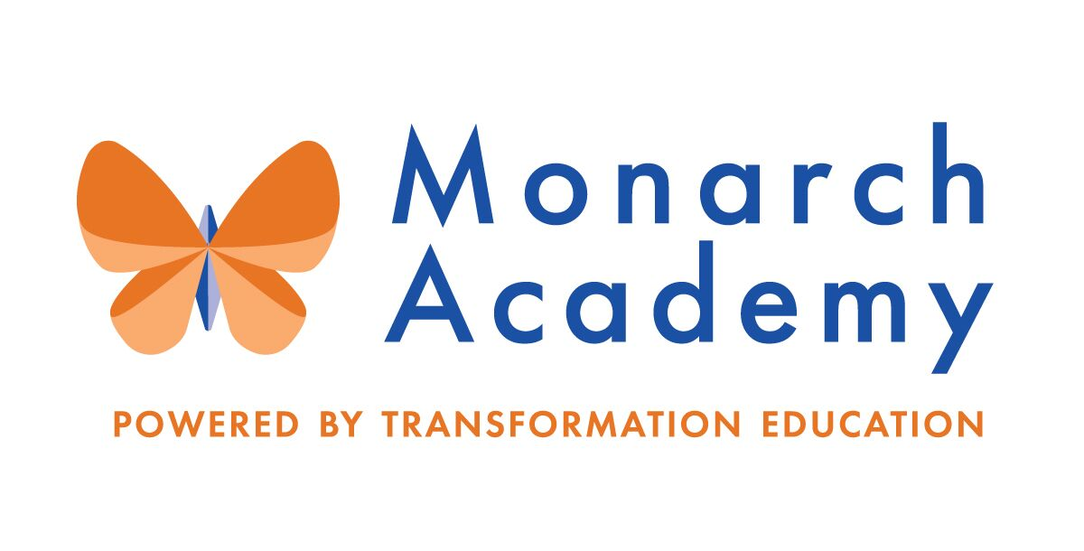
Monarch Academy, Anne Arundel
Board of Directors Meeting
September 8, 2021
ZOOM
6:00 - 8:00 p.m. OPEN BOARD MEETING

Attendees | Not in Attendance | Monarch Staff | The Children’s Guild
Dr. Sissy Jimenez  Kandace Hoppin  Brittany Jones  Loise Taliaferro  Jess Deinlein  Megan Philbeck  Janine Fratantuono | Carley Czyzewski  Marc Rodriquez  Amber Marcheso  Ray Szyperski  Shae Delfino  Eric DeVito  Angela Balsamo | Charlette Manbeck, Annapolis  Kim Jakovics, Glen Burnie  Donna O’Shea, Global  Emily Abell, Global | Kathy Lane  Aleisa Fries  Brandon Turner  Charley Gordon
Minutes

- Call to Order – Dr. Jimenez
Monarch Anne Arundel Board Meeting called to order at 6:07pm by Dr. Jimenez

- Public Comment – Dr. Jimenez
None
- Review Minutes – Dr. Jimenez
The meeting minutes from June 9th meeting were reviewed and approved.
- Principal’s Report
- Monarch Glen Burnie – Ms. Jakovics
https://www.smore.com/9yetp
- Monarch Glen Burnie spent the summer revising the school’s mission, vision and belief statements in collaboration with community stakeholders, parents, students and staff
- Focused on Brain Literacy. Participated in Trauma Informed activity that explains how trauma impacts the brain, how to understand the result of this and how to incorporate different methods of teaching to accommodate
- Issues with transportation/bus driver shortages
- Contract renegotiations with current bus company will occur
- Secured (4) additional buses through a new bus company with the intent to resolve the issue
- MAGB and MAA are two drivers short, and MGA is one driver short
- Greenhouse Update
- Ran into some permitting issues and needed to develop a new Greenhouse with a second egress door
- A plan is in place to add the turf field and basketball court while greenhouse is being permitted
- Monarch Global – Ms. Abell
https://www.smore.com/nze97
- Ms. O’Shea announces that she will be retiring as Principal on February 1, 2022
- Ms. Abell will transition from Assistant Principal to Principal on February 1, 2022
- Middle school has restructured Wednesday professional development/instructional days to “Exploration Days” based on student selected topics. This is an innovative way for teachers to honor the student’s voice and choice
- MGA welcomed 14 new teachers to the school
- New teachers will become part of the “Transformation Team”. The Transformation Team is a group of new teachers that offers individualized and differentiated professional development to focus on what it is like to be a teacher at Monarch
- Monarch Annapolis Ms. Manbeck
- The Board welcome Monarch Annapolis’ new Principal, Charlette Manbeck
- MAA also welcomed 1 new Assistant Principal and 18 additional new team members to the school
- This summer was focused on connecting the school to the community as a whole
- MAA partnered with Monarch Annapolis PTA and Boy Scouts to have 3 free little libraries installed around the school property for families and the community to borrow and donate books
- MAA partnered with a non-profit food pantry, Blessed in Tech Ministries, to distribute over 1000 pounds of free food, games, toys, diapers and school uniforms to Annapolis families
- Construction Updates
- Penthouse renovation is underway- expected completion (without permitting issues) by the end of this calendar year
- New construction of apartments is almost complete- The school will remain in contact with the developers to determine when the apartments will become occupied, and correspondence will follow to families

- Board membership – Dr. Jimenez
  - Board member Terms and update
- Up for renomination:
Sissy Jimenez
Loise Taliaferro
Jess Deinlein
- The Board approves renomination of the 3 board members (listed above) to continue for an additional term
  - Nominations of new members
- Dr. Jimenez nominates Ms. Hoppin as Co-Chair
- Ms. Hoppin accepted nomination for this position
- The Board voted to approve appointing Ms. Hoppin as the Co-chair of the Board for the remainder of this school year
  - Meeting calendar 2021-22
- Calendar was approved via email vote
- Meetings will continue Virtually

- Committee Membership- Appoint Chairs and Committee members – Dr. Jimenez
All additional members of the Board and members appointed to each committee should include individuals that have different and diverse areas of expertise. These committees are expected to meet separately as a team and report out at each Board meeting. These subgroups/committees are a requirement of the Board as articulated in the Bylaws.
- Dr. Jimenez asks that Board members think of connections within their network that could be considered as new Board members
- Send Ms. Lane and Dr. Jimenez the resume for consideration
- Dr. Jimenez will initiate an introduction meeting with potential new members

- Current Financial Report – Mr. Gordon
- Mr. Gordon presents analysis from 6/30/21, end of fiscal year.
- The numbers presented are unaudited and subject to change
- Current year revenues (for the Organization as whole) came in below budget but ahead of prior year revenues
- Current year operating expenses were below the budget but larger than last year

- Other Business
  - Current Enrollment by school and Recruitment Strategy – Mr. Turner
- Enrollment remains steady for all 3 schools
- Monarch Annapolis has almost hit enrollment goals
- This is a major accomplishment for the school and Admissions team!
- Dr Jimenez reminds the Board of the Kids First celebration honoring Dr. Ross that will be held on November 6, 2021 at 6:30pm.

- Adjournment – Dr. Jimenez
Monarch Anne Arundel Board Meeting adjourned at 7:33pm.

