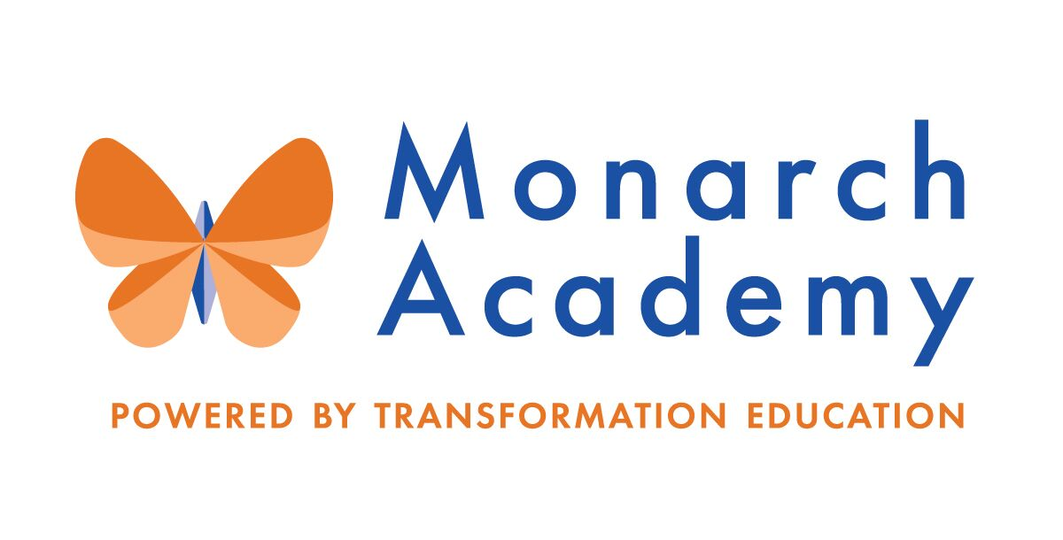
Monarch Academy, Anne Arundel
Board of Directors Meeting
June 9, 2021
ZOOM
6:00 - 8:00 p.m. OPEN BOARD MEETING

Attendees | Not in Attendance | Monarch Staff | The Children’s Guild
Dr. Sissy Jimenez  Carley Czyzewski  Kandace Hoppin  Elizabeth Noble  Brittany Jones  Loise Taliaferro  Jess Deinlein | Marc Rodriquez  Amber Marcheso  Megan Philbeck  Ray Szyperski  Shae Delfino  Eric DeVito  Janine Fratantuono  Angela Balsamo | Paul DeRoo, Annapolis  Kim Jakovics, Glen Burnie  Donna O’Shea, Global | Kathy Lane  Aleisa Fries  Brandon Turner  Charley Gordon
Minutes

- Call to Order – Dr. Jimenez (6:00 pm)
Monarch Anne Arundel Board Meeting called to order at 6:02pm by Dr. Jimenez

- Public Comment – Dr. Jimenez
The Children’s Guild and Monarch Academy Board welcomes the new PTA President at Monarch Glen Burnie, Brittany Jones.
- Review Minutes – Dr. Jimenez
The meeting minutes from February 10th and April 14th meeting were reviewed and approved.
- Principal’s Report
Principals and teachers by are recognized by Ms. Lane, Chief Education Officer, for “showing great passion, compassion, dedication and resilience throughout this challenging school year.”
- Monarch Annapolis – Mr. DeRoo, Acting Principal
- MAA now has 2 Assistant Principals; looking to hire one more
- Ms. Amstutz, Principal, is still on leave
- The Board will be notified when this status changes
- School Improvement Plan (SIP), Primary Years Programme (PYP) and Vision Planning: areas of focus presented
- Transformation Theatre Camp starts on July 5, 2021(link below)
- Summer School PreK starts on July 6, 2021
- Monarch Glen Burnie – Ms. Jakovics
https://www.smore.com/974n3
- Currently in the permitting phase for outdoor renovation
- Projected date of completion is September 2021
- Raised $30,000 for greenhouse by having a fundraiser at the school
- Providing one-on-one tutoring through Huntington Learning Center for 40 students
- Students participated in Student Lead Conferences with staff and peers
- “Better World Day” allowed an opportunity for students to participate: in a live, virtual session with artist, Kyle Yearwood. Mr. Yearwood focuses on finding one’s purpose and using one’s talents to make a difference
- Students made activity books for children of the firefighters who staffed the vaccination clinic for AACPS
- Leadership examined and analyzed student work to determine needs for growth (done twice annually)
- Monarch Global – Ms. O’Shea
https://www.smore.com/1qecy
- The school sent out a flier to feeder schools in the surrounding areas with the intent to recruit new students for kindergarten and first grade
- Advancement Via Individual Determination (AVID) interviews are underway to determine AVID 6th grade class for SY21-22. Goal is to encourage students to attend college
- Positive Behavior Intervention System (PBIS): Adopted three Ron Clark Houses, a nonprofit providing shelter and resources to homeless families. House members are washing cars to raise money for the houses
- Continuing to hold monthly coffee talks with parents
- Collaborative Student Inquiry (CSI): 8th grade students have submitted final project to give feedback about experiences at MGA- please read!
- PTA Update: Students are investing “dojo dollars” into charities of their choice. The PTA is taking those funds and donating “real dollars” to those chosen charities

- Board membership – Dr. Jimenez
  - Board member Terms
- Vacant Positions: Vice Chairperson, Secretary and Treasurer
- Bylaws attached to define position descriptions:
  - Nominate Officers for 2021-22
- 3 current Board members are up for renomination in 2021:
Sissy Jimenez (Chair)
Loise Taliaferro
Jess Deinlein
- Renomination can not occur at this meeting due to lack of quorum
- Those up for renomination should send an email to the Board members to seek approval for renomination or wait until next meeting when a quorum is present
  - Nominations of new members
- Asking each Board member to reach out to professional network with intent to fill seats and build a more robust, engaged Board in the fall
- The Board is asking The Children’s Guild to consider hosting an open house or retreat to “meet and greet” potential new members
- All Board members should send resumes and contact information to Ms. Lane and Ms. Jimenez for review and introduction.
- Asking each Board member to invite one person/potential candidate to next meeting in September
  - Meeting calendar 2021-22
- Ms. Lane has proposed the Board Meeting calendar for upcoming school year for approval
- Meetings will start in September this year rather than August and be held every other month to follow
- Schedule can not be approved at this meeting due to lack of a quorum. E-mail will be sent for vote post meeting.

- Committee Membership- Appoint Chairs and Committee members – Dr. Jimenez
The Children’s Guild is suggesting that once the Board has participation at capacity, members should express their interest to be appointed into at least one of the following committees:
  - Governance Committee
  - Marketing, Enrollment, Finance & Facilities Committee (MEFF)
  - Parent Engagement, Academic Excellence & Compliance Committee (PEAC)

- Current Financial Report – Mr. Gordon (7:30 – 7:40 pm)
- Mr. Gordon presents budget as of 4/30/2021 due to timing of report

- Other Business (7:40 – 8:00 pm)
  - Current Applications and Recruitment Strategy – Mr. Turner
- MAA continues to be the primary focus of the Admissions team
- School registration is active and open until September 30th at 4pm or until school is at capacity
- Mr. Turner has created a “Think Tank” group to think of new marketing initiatives and ideas from the school staff and community
- Upcoming events and community outreach efforts presented
- The Open House at MAA is next Wednesday, June 16th at 4pm
- Brandon will send a link to the Board members for registration
- The Board is requesting advance notification of events for participation
- Mr. Turner and Ms. Lane will follow up re: AACPS magnet school open houses
- The Board suggests to consider selling spirit wear and collateral
- The Children’s Guild has partnered with Land’s End to make spirit wear. Monarch Academy will consider joining in this effort
- Monarch Academy car magnets and graduation yard signs have been ordered and will be distributed to families prior to the last day of school
  - Transformation Theatre Co. Summer Camp - Ms. Lane
https://monarchacademy.org/camp/
- Grant has allowed MAA to offer scholarships for camp.
- The camp is open to rising Pre-K to rising 8th grade students in Anne Arundel County.
Camp Budget and Registration update (to date):
  - Other Business
- The Board Chair will send a letter to the Principals and school leaders acknowledging their service and thanking them for their efforts this year
- Adjournment – Dr. Jimenez (8:00 pm)
Monarch Anne Arundel Board Meeting adjourned at 7:54pm.

