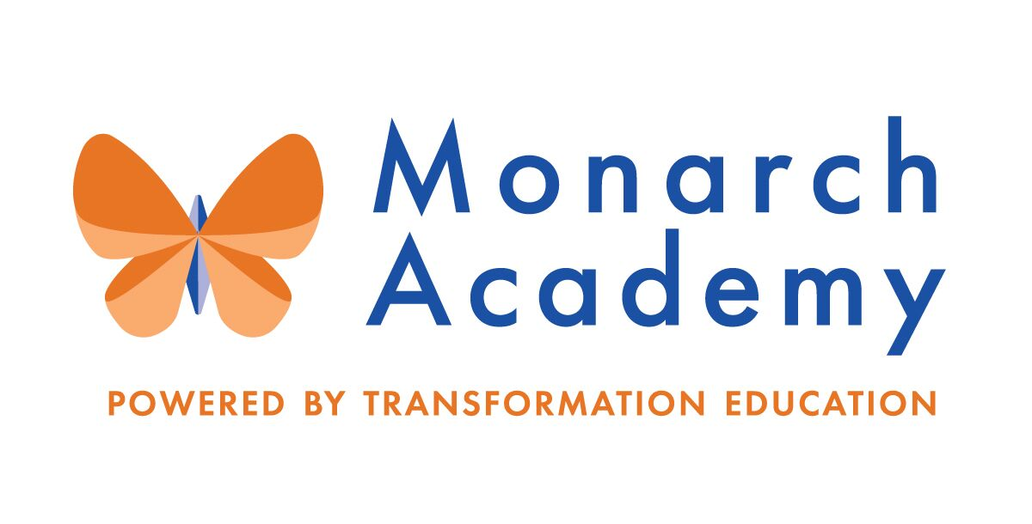
Monarch Academy, Anne Arundel
Board of Directors Meeting
April 14, 2021
ZOOM
6:00 - 8:00 p.m.

Attendees | Not in Attendance | Monarch Staff | The Children’s Guild
Dr. Sissy Jimenez  Eric DeVito  Carley Czyzewski  Kandace Hoppin  Janine Fratantuono  Angela Balsamo  Elizabeth Noble | Marc Rodriquez  Jess Deinlein  Loise Taliaferro  Amber Marcheso  Megan Philbeck  Ray Szyperski  Shae Delfino | Paul DeRoo, Annapolis  Kim Jakovics, Glen Burnie  Emily Abell, Global | Jenny Livelli  Kathy Lane  Aleisa Fries  Brandon Turner  Charley Gordon
Meeting Minutes

- Call to Order – Dr. Jimenez
Monarch Anne Arundel Board Meeting called to order at 6:04pm by Dr. Jimenez
- Public Comment – Dr. Jimenez
None
- Introduction of Jenny Livelli, new President & CEO – Dr. Jimenez
Jenny Livelli introduced as new President and CEO for The Children’s Guild.
- Review Minutes – Dr. Jimenez
Meeting minutes from February 10th meeting were reviewed but could not be approved due to lack to quorum.
- Principal’s Report
- Monarch Glen Burnie – Ms. Jakovics
https://www.smore.com/hdzqv
  - The outdoor classroom & recreational space development project is moving forward as planned.
- The goal is to raise $20, 000 for the inside of the greenhouse with fundraiser incentives through Boosterthon/FunRun
  - Professional Development is focused on Diversity, Equity, Inclusion and Anti-Racism with guest speakers:
- Kyle Yearwood-spoke about his artwork
- Board Members from Magic Gardens in Philadelphia
- Founder of Minds on Fire
- Many more to follow!
  - Social Justice Club (middle schoolers at MGB) started a podcast; first episode was on how racism has affected them. View here: Podcast
  - Upcoming student led conferences will be held on May 19 & 26th , 2021.
  - Using CARES grant money to provide Social-Emotional trauma professional development seminar for teachers at the end of the school year.
  - School will be featured by Expeditionary Learning (EL Education).

- Monarch Global – Ms. Abell
MGA Board report
- CARES Grant funding is still being utilized for technology upgrades, student supplies and enriched experiences at the school.
- Interior upgrades are completed: flooring in media center was replaced and living wall at entry was refreshed.
- The staff book study continues to read: “White Fragility” and “Coaching for Equity”.
- The Support team continues to host monthly “Coffee Talks” with parents to assist parents with supporting their students’ needs.
- New playground is now open and students (and staff) are loving it!
- The school was re-accredited by International Baccalaureate Program.

- Monarch Annapolis – Mr. DeRoo
MAA Board Report
- Introduction of Mr. Paul DeRoo, Acting Principal
- Mr. DeRoo is concentrating on school climate control, infrastructure, mentoring of staff, community connection and planning for the School Improvement Plan (SIP), 21-22 SY goals, budget and staffing.
- Using CARES Funding for student tutoring
- Now offering 15 online clubs to include: Nature, Ukulele, Chess, Art, Bucket Band, etc.)
- PTA/Boosterthon raised nearly $30,000 this cycle for school needs.
- E-School at MAA celebrated its first year with 104 students and above 95% attendance rate.
- MAA continues to establish proactive strategies to promote positive student behaviors and coping skills.
- Open House: April 17th at 11:00am.
- Proposed Committee Structure – Ms. Lane
- The Children’s Guild/Kathy Lane is proposing to establish subcommittees within the Board to oversee the functions of the schools.
- Board Members to select their team at next meeting.
    - Governance Committee
- Need focus on recruitment for additional, more diverse Board members
- Current Board President term ends June 2021
- Need Vice Chair
    - Marketing, Enrollment, Finance & Facilities Committee (MEFF)
    - Parent Engagement, Academic Excellence & Compliance Committee (PEAC)
- Ms. Lane will provide committee roles and responsibilities by next meeting.

- Current Financial Report – Mr. Gordon
- Mr. Gordon reports out for the quarter through February as the availability of the analysis is a month behind.
- Total operating expenses are running below projected budget and ahead of last year expenses- great news!
- Starting next meeting, Mr. Gordon will present comparison of budgets from other Non-profits to the Monarchs.

- Other Business
  - Current Applications and Recruitment Strategy – Mr. Turner
- Waitlist for Glen Burnie and Global
- GB- 517
- Global- 57
- Annapolis continues to be the primary focus for the Admissions and Marketing team efforts.
- Need 247 more students to reach MAA Goals
- Yard signs will be distributed to graduates of each school
  - Transformation Theatre Co. Summer Camp - Ms. Lane
- The Children’s Guild is hosting a 6-week camp at Monarch Academy Annapolis this summer for the purpose of marketing and to introduce the new Arts Integration program at our schools.
- Camp is open to any student, grade K-8, that resides in Anne Arundel County.
- Asking all Board members to promote the camp.
  - Other Business (if any)
The (2) ‘Teacher of the Year’ candidates Monarch Schools will be recognized by Anne Arundel County Board of Education tomorrow, April 15th at 6:30pm:
- Sonja Bolotin – MGB
- Maria Cummings - MGA
- Adjournment – Dr. Jimenez
Monarch Anne Arundel Board Meeting adjourned at 7:59pm.

