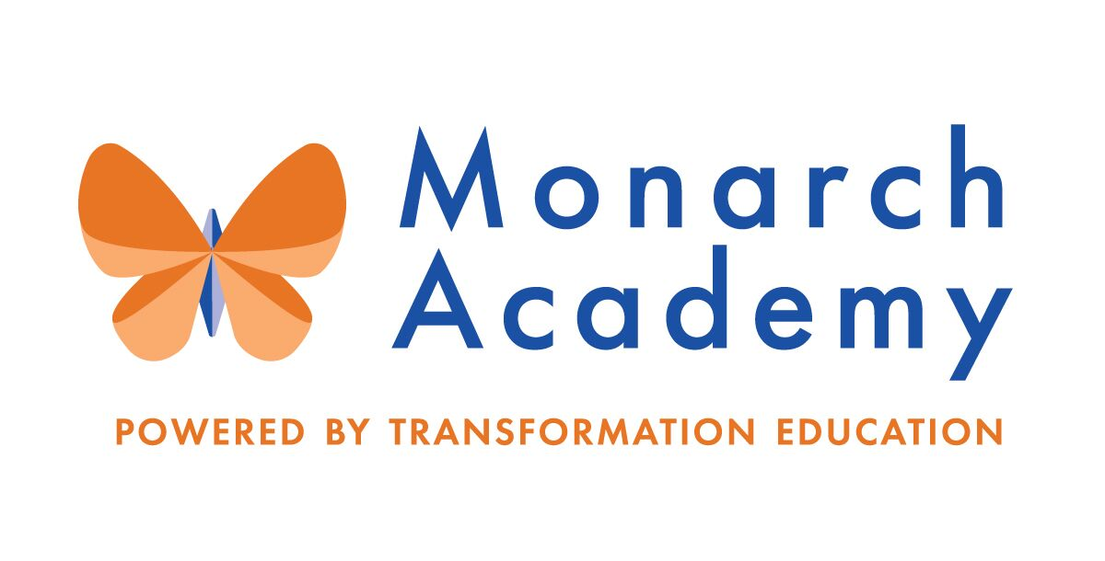
Monarch Academy, Anne Arundel
Board of Directors Meeting
February 10, 2021
ZOOM
6:00 - 8:00 p.m. OPEN BOARD MEETING

Attendees | Not in Attendance | Monarch Staff | The Children’s Guild
Dr. Sissy Jimenez  Eric DeVito  Loise Taliaferro  Carley Czyzewski  Kandace Hoppin  Megan Philbeck  Janine Fratantuono  Ray Szyperski  Jess Deinlein  Shae Delfino  Derek Matthews | Elizabeth Noble | Rachel Amstutz, Annapolis  Joel Garcia, Glen Burnie  Donna O’Shea, Global | Dr. Andrew Ross  Kathy Lane  Aleisa Fries  Dr. Gary Kellner  Brandon Turner  Francisca Koduah  Miguel Vicente  Charley Gordon
Meeting Minutes

- Call to Order – Dr. Jimenez
Monarch Anne Arundel Board Meeting called to order at 6:06 pm by Dr. Jimenez.
- Review Minutes – Dr. Jimenez
Meeting minutes from the October 14 and December 9, 2020 meetings were reviewed and approved by Board.
- Movement of Funds between Children’s Guild Alliance Entities – Mr. Gordon
- The formal “Funds Transfer Form” that will be used to officially transfer funds throughout entities presented.
- A subgroup of the Board will be formed to review all funds transfer requests.
- Financial Update – Mr. Gordon (attach)
  - 2nd Quarter Financials presented
  - Audit presented
- Monarch Glen Burnie Outdoor Classroom & Recreational Space – Mr. Garcia & Ms. Koduah
  - DESIRED ACTION: Approval to move forward with landscape architect creating plans to submit to Anne Arundel County to turn parking lot into turf and basketball court and build a greenhouse/outside classroom.
- Anticipated completion date: August 30.
- The PTA plans to have a fundraiser in April to assist with funds for supplies needed in the greenhouse/outside classroom. Other funding will be handled by grants or Children’s Guild surplus cash allocated for capital projects.
- Motion to approve the design plan: APPROVED subject to review and approval of lease matters by subgroup consisting of: Ms. Czyzewski, Ms. Taliaferro, Mr. DeVito, Ms. Delfino And Dr. Jimenez.

- Current Applications and Recruitment Strategy – Mr. Turner
- Still need 250 registrations to hit the target goal at MAA, waiting on approval from the county (anticipating March/April) to open registration.
- The focus is on branding and promoting “Monarch Academy” as a whole.
- The Admissions Teams collaborated with The Children’s Guild Diversity, Equity and Inclusion (DEI) group to host community events focused on Black History Month. Videos are available on the MAA website.
- Upcoming event invitations will be sent to all Board members.
- Introduction of Miguel Vicente, The Children’s Guild new bi-lingual facilitator and community liaison.
- All Board members are encouraged to send additional contacts for potential community partnerships.

- Plan for Hybrid ReEntry– Ms. Lane/Principals
All guidelines and processes have been followed to adhere to all CDC guidelines, to include but not limited to: Accessibility to PPE, classroom set up, visitor sign-in for contract tracing, isolation rooms, high touch cleaning throughout the day, technology infrastructure upgrade, etc.
Timeline for ReEntry:
February 17: All Monarch staff will return to building unless approved by AACPS or TCG for health or childcare accommodations.
March 1: Pre-k to 5 will return (About 35% have decided to come back)
March 8: 6th grade will return
March 22: 7 and 8th graders will return
Schedule for Re-Entry:
Monday and Tuesday (A-Day), Thursday and Friday (B-Day).
All Schools closed Wednesday for virtual instruction and deep cleaning.
Number of students returning:
Global: 250; 125 on A-Day, 125 on B-Day
Glen Burnie: 223; 112 on A-Day, 112 on B-Day
MAA: 244; 122 on A-Day, 122 on B-Day

- Mission Advancement Report – Dr. Kellner
- The Children’s Guild was able to provide food support to 11,000 families between May and December. Distributed more than 50,000 pounds of food.
- An overview of efforts and upcoming events were presented to include social media campaign outcomes and donor ratio and allocation of donations.

- Principal’s Report
- Monarch Annapolis – Ms. Amstutz
MAA Board Report
Used grant funds for EdCamps- several sessions offered for teachers and families for themes to focus on Academics, Social Emotional, Unique Learner Needs, Technology and General School Topics and racket books. Continuing partnership with Huntington for student tutoring.
Construction Projects:
Library Space Renovation- Nearing completion.
Penthouse- Partially done, second phase in summer. Resource and canopy classrooms opened.
Housing Complex- 5 new buildings built, still ongoing.
- Monarch Global – Ms. O’Shea
https://www.smore.com/1qecy
- Cares Grant used for technology, software subscriptions and updates, supplies and workbooks, PPE for staff and students and new motivating clubs to focus on coding, robotics, drama, etc.
- Hosting monthly “Coffee Talks” with parents for feedback.
- Monarch Glen Burnie – Joel Garcia (link)
https://www.smore.com/z6whk
- Academic Performance: Based on DIBELS, K and Grade 1 students ranked in the top 13 schools in AACPS for the percentage of students at and above the threshold for increased reading intervention!
- Sent out a climate survey to assess how students were feeling as part of the Monarch community. Results were analyzed and next steps “to address students’ perceptions through crew, social skills lessons and individualized/ small group interventions” were determined.
- Student group equity tracking presented to present student climate data.

- Other Business
Mr. Szyperski advised that the Anne Arundel County School Board will donate roughly $20K to fund charging carts at Monarch Global.

- Transformation Theatre Co. Summer Camp - Ms. Lane
Camp will be held at Monarch Academy Annapolis starting in July.

- Adjournment – Dr. Jimenez
Monarch Anne Arundel Board Meeting adjourned at 8:34 pm.

